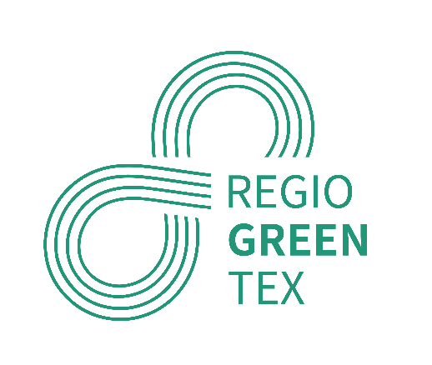**REGIOGREENTEX**

**Subscribe to our**[**newsletter**](https://mailchi.mp/89740fa932b9/regiogreentex-newsletter)**﻿﻿﻿﻿**

**Strengthening innovative textile  
circularity in Europe’s regions**

In the framework of the European Green Deal, RegioGreenTex is a project promoting the collaboration in research and development for the textile industry to establish a systematic circular economy business model across the EU.

**OBJECTIVES﻿**

**1. MAP NEEDS**

Map the needs and potentiality in the implementation of a circular economy among European regions and clusters and their different levels of economic development.

**2. BUILD ECOSYSTEM**

Build a dynamic recycling textile ecosystem at European level by making demand and offer meet on a shared digital platform.

**3. SUPPORT SMEs**

Support SMEs pilot projects to accelerate the creation, development and use of new textile materials with increased recycled content by sharing technologies and methodologies.

**4. CREATE HUBS**

Create five regional textile recycling hubs in line with the ReHubs initiative and consistent with the EU textile strategy and with the needs of SMEs.

**5. GENERATE INVESTMENT**

RegioGreenTex ultimately aims at generating investment opportunities at regional level beyond the project.

**PARTNERS**

RegioGreenTex promotes the collaboration in research and development between 43 partners from the four major sectors of society – industry, government, research institutes, and the public – for the textile industry. Partners come from 11 regions in 8 European countries:  
  
– Flanders (BE)  
– East Netherlands (NL)  
– Hauts-de-France & Auvergne-Rhône-Alpes (FR)  
– Piedmont & Tuscany (IT)  
– Norte Portugal (PT)  
– North East Romania (RO)  
– Catalunya & Valencia (ES)  
– Västra Götaland (SE)

Top of Form

